**Structure document for**

**VOIS API REST Assured Task**

**Purpose:**

The purpose of this document is explaining the project structure and all tools and technologies that used in this project

**Project Structure:**

The project structure is as the following:

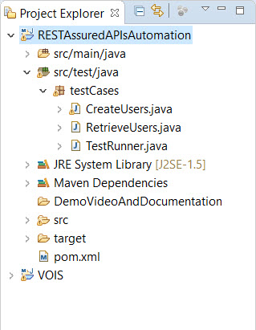

**1- src > test > java > testCases**

This folder containing 3 packages:

1. **CreateUsers**: containing a method that fires create new user request.
2. **RetrieveUsers**: containing methods that get the user data, either all users’ data or just one user’s data.
3. **Test Runner**: containing the main method that runs all needed methods with the required sequence.

**5- pom.xml:** containing all project dependencies.

**Used tools and technologies:**

* Eclipse IDE
* Maven
* Testng
* io.rest-assured
* hamcrest
* com.googlecode.json-simple